Exercise 3: Assertions in JUnit

**Used different assertions in JUnit to validate my test results.**

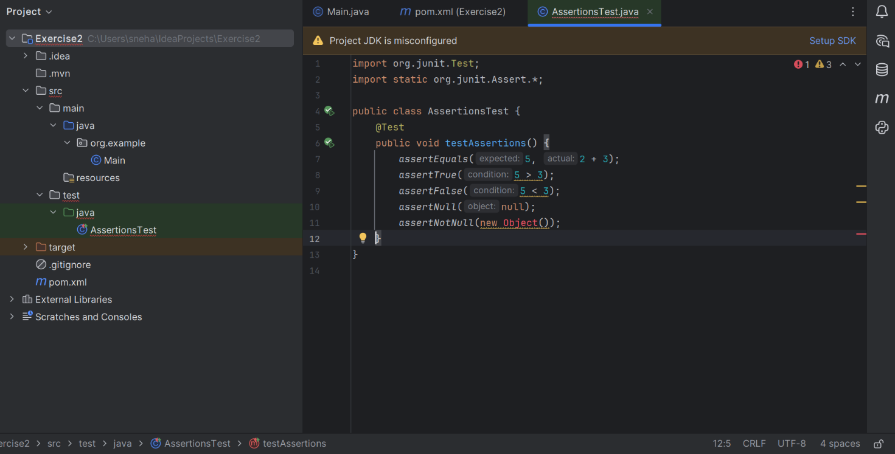

**OUTPUT:**

